**25.4. Lazy Fetching Close the Session**

**Lazy Fetching Close the Session**:

1. When we use lazy load, the data is only retrieved on demand.
2. However, this requires an open Hibernate session.
3. We need a connection to database to retrieve data.
4. If the hibernate session is closed and we attempt to retrieve lazy data Hibernate will throw an exception

**File: LazyFatchingCloseSession.java**:

Now in our main app (**LazyFatchingCloseSession.java**) we will close our session and try to get the courses.

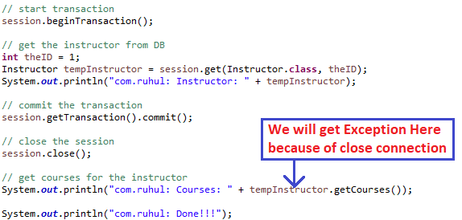

**RuntimeException**:

Exception in thread "main" org.hibernate.LazyInitializationException: failed to lazily initialize a collection of role: com.ruhul.odduu.hibernate.entity.lazy.Instructor.courses, could not initialize proxy - no Session

. . . .

At com.ruhul.odduu.hibernate.demo.LazyFatchingCloseSession.main( LazyFatchingCloseSession.java:43)

**File: LazyFatchingCloseSession.java**

**package** com.ruhul.odduu.hibernate.demo;

**import** org.hibernate.Session;

**import** org.hibernate.SessionFactory;

**import** org.hibernate.cfg.Configuration;

**import** com.ruhul.odduu.hibernate.entity.lazy.Course;

**import** com.ruhul.odduu.hibernate.entity.lazy.Instructor;

**import** com.ruhul.odduu.hibernate.entity.lazy.InstructorDetail;

**public** **class** LazyFatchingCloseSession {

**public** **static** **void** main(String[] args) {

// create session factory

SessionFactory factory = **new** Configuration(). configure("hibernate.cfg.xml").

addAnnotatedClass(Instructor.**class**).

addAnnotatedClass(InstructorDetail.**class**).

addAnnotatedClass(Course.**class**).

buildSessionFactory();

// create session

Session session = factory.getCurrentSession();

**try** {

// start transaction

session.beginTransaction();

// get the instructor from DB

**int** theID = 1;

Instructor tempInstructor = session.get(Instructor.**class**, theID);

System.***out***.println("com.ruhul: Instructor: " + tempInstructor);

// commit the transaction

session.getTransaction().commit();

// close the session

session.close();

// get courses for the instructor

System.***out***.println("com.ruhul: Courses: " + tempInstructor.getCourses());

System.***out***.println("com.ruhul: Done!!!");

} **finally** {

// add clean up code

session.close();

factory.close();

}

}

}

**Solution**:

We can solve this Exception in two ways.

1. **Option 1**: session.get() and call appropriate getter method(s)
2. **Option 2**: Hibernate query with HQL

**Option 1: session.get() and call appropriate getter method(s)**:

We have to call the getter() method while session is open

25.4. Lazy Fetching Close the Session